Map Marker Icon Area Tags

# Description

The TourTrak application includes three different font sets: Awesome font, custom icons from flaticon, and custom icons provided by the designers @ BikeNY. In the description of each marker, include [AREA][/AREA] tags. For example, the medical marker description should include in it [AREA]Medical[/Area].

# Awesome font icons

Medical Food Music Sagtruck

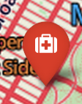  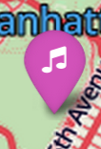 

Warning Mechanics

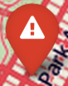 

# Flaticon font icons

Bathrooms Rest_area Rendesvous_spot Lost_Child

   

Subway Timed_ride

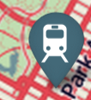 

# BikeNY icons

Vest Trash Picture Award

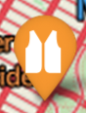   

Ferry Car Food2 Tshirt

   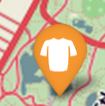

Mechanic2 Ribbon Recycle Tshirt2

   

Search Helmet License Info-tent

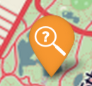  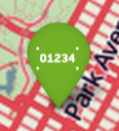 

# Notes:

Icons are not as sharp as in the map due to them being scaled up in the Word document.

# Font Licenses

The font awesome icons is made by Dave Grandy – <http://fontawesome.io> under the GPL license.

The flaticon font was generated by [flaticon.com](http://www.flaticon.com) under [CC BY](http://creativecommons.org/licenses/by/3.0/). The authors are: [Freepik](http://www.freepik.com), [OCHA](http://http://www.unocha.org), [Scott de Jonge](http://www.scottdejonge.com).

Designers at BIkeNY created the Bike NY icons. <http://www.bikenewyork.org/>